**Topic:** Tooth Abscess Stages in 2022 – Vigoursoul

**Focus keyword:** Tooth Abscess Stages

**Meta Title:** Tooth Abscess Stages in 2022 – Vigoursoul

**Meta Description**: "Today, our Edmonton dentists discuss the stages of a tooth abscess, why they form, and how they can be treated."

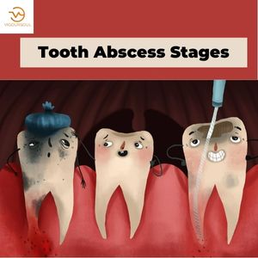

A dental abscess is a collection of pus that can form inside the teeth, the gums, or the bone that supports the teeth. A bacterial infection is to blame. A periodical abscess is an abscess that develops at the tip of a tooth. Periodontal abscess refers to a gum abscess.

**Types of Tooth Abscess:**

 Dental abscesses are categorized according to where they originate in the mouth. They are as follows:

* **Gingival Abscess** - This gum abscess develops on the gum tissue's surface. Most people compare it to a little but noticeable pimple. A gingival dental abscess is simple to treat and recover from if caught early.
* **Periodontal Tooth Abscess** - This type of abscess occurs deeper into the gums, namely in the gum pockets. A periodontal tooth abscess can readily spread to surrounding bone and tissue because the fluid has nowhere to flow.
* **Periodical Abscess** - Can erode the protective enamel and softer inner dentin of a tooth. Once it reaches the dentin, it can readily attack the fragile inner pulp, which contains the nerves of the tooth. This is the point at which extreme pain occurs. The only way to save the tooth from this sort of abscess is to have a root canal.

**Tooth Abscess Stages:**

Now that we've established what a dental abscess is and where it might originate, we should go through the different tooth abscess stages. Keep in mind that an abscessed tooth develops gradually and that a succession of dental problems and distinct stages must occur. These are the following:

1. **Decay of Enamel:**

Plaque produces a buildup of bacteria in the mouth, which leads to the formation of pus and, eventually, a dental abscess. Plaque can build up on gums and tooth surfaces if we do not brush our teeth frequently or thoroughly enough to remove plaque from our teeth and along the gum line. Acid can build on the tooth enamel and dissolve it. A cavity forms when tooth decay begins.

1. **Decay of the Dentin:**

Bacteria continue to eat their way through the enamel and invade the dentin if you do not visit your dentist soon enough to have the cavity filled (sub-layer).

1. **Infection in the Tooth Pulp:**

After the bacteria have destroyed the dentin, it might invade the tooth's inner pulp. When this happens, the nerves within the tooth die, and the immune system of the body begins to battle the infection. Pus then forms around the dying roots, resulting in a tooth abscess.

1. **Abscess Development:**

You may detect pain surrounding the tooth, as well as gum redness and swelling, in the later stages of tooth decay, once the bacteria has invaded the pulp of the tooth or made its way further into the gums or jawbone. Fever can be caused by a serious abscess.

1. **Tooth Decay:**

By this point, discomfort or throbbing pain should alert you to the presence of a tooth abscess and prompt you to visit your dentist. The abscess has reached a critical stage and should be treated as soon as possible. If the tooth or dental abscess is not treated, the abscess can erode the bone further, resulting to tooth loss.

**Tooth Abscess Stages x ray:**

How fast does a tooth abscess grow? Abscesses can form in as little as one or two days following the first signs of infection. They can progress undiagnosed and so untreated for months or even years.

**Tooth Abscess Stages Symptoms:**

The following are signs and symptoms of a tooth abscess:

* A severe, throbbing toothache that might spread to your jawbone, neck, or ear.
* Hot and cold temperatures cause pain or discomfort.
* Pain or discomfort caused by chewing or biting pressure
* Fever
* Face, cheek, or neck swelling that may cause trouble breathing or swallowing
* Tender, swollen lymph nodes in your neck or beneath your jaw
* Bad taste in your tongue
* If the abscess ruptures, you will experience a sudden rush of foul-smelling and foul-tasting, salty fluid in your mouth, as well as pain alleviation.

**Causes :( Tooth Abscess Stages)**

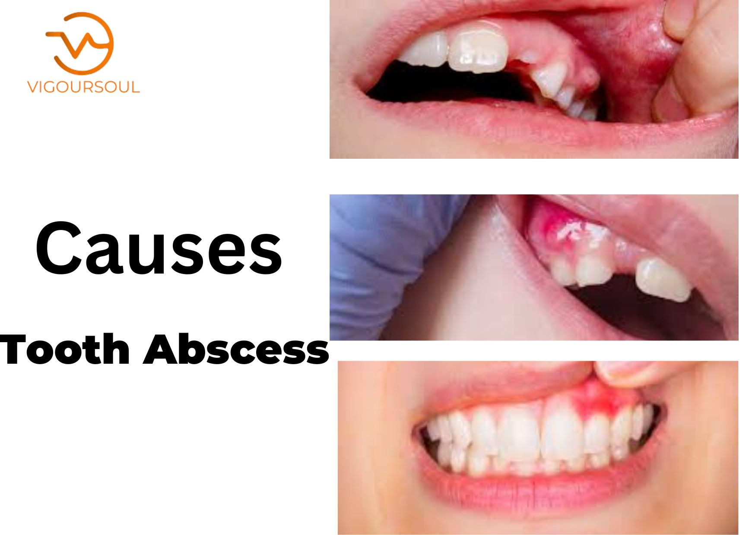

* When germs infiltrate the dental pulp, a periodical tooth abscess develops. The pulp is the interior component of the tooth and is made up of blood vessels, nerves, and connective tissue.
* Bacteria enter the tooth through a dental cavity or a chip or fracture and spread all the way down to the root. Swelling and inflammation at the root tip might result from bacterial infection.

**Risk Factors:**

These variables may raise your chances of developing a tooth abscess:

* **Inadequate dental habits and care**. Not caring for your teeth and gums properly, such as brushing twice a day and flossing, might raise your risk of dental diseases. Tooth decay, gum disease, tooth abscess, and other dental and mouth issues are all possibilities.
* **A high-sugar diet**. Sugary meals and beverages, such as sweets and sodas, can contribute to dental cavities and lead to a tooth abscess.
* **The mouth is parched.** Dry mouth can raise your chances of developing tooth decay. Dry mouth is frequently caused by a side effect of some drugs or by age concerns.

**Prevention:**

Tooth decay must be avoided in order to avoid a tooth abscess. To avoid tooth decay, take proper care of your teeth:

* Fluoride-containing water should be consumed.
* Brush your teeth for two minutes with fluoride toothpaste at least twice a day.
* Clean between your teeth on a daily basis using dental floss or a water flosser.
* Replace your toothbrush every three to four months, or anytime the bristles get ragged.
* Consume healthful foods while limiting sugary foods and between-meal snacks.
* Check in with your dentist on a regular basis for checkups and professional cleanings.
* To give an extra layer of protection against tooth decay, use an antiseptic or fluoride mouth rinse.

**Tooth Abscess Stages Treatment:**

As with most other dental conditions, the sooner you call your Edmonton dentist to get a tooth abscess treated, the better the outcome for your smile – and your long-term health.

Several factors will influence treatment, including:

* The abscess's initial location
* Whether or not the infection has spread, and how far it has spread
* The magnitude of the immune system's response to the infection

**FAQS:**

**How quickly does a Tooth Abscess Progress?**

Abscesses can form in as little as one or two days following the first signs of infection. They can progress undiagnosed and so untreated for months or even years.

**How serious is an abscess tooth?**

A tooth abscess is a true dental emergency. If you have a tooth abscess, you should seek treatment right once. Abscess, if left untreated, can cause infection to spread throughout the body, bringing significant and even life-threatening consequences. The sooner these problems are addressed, the better!

**What will dentist do for abscessed tooth?**

If draining the abscess is not an option, a root canal is the next best thing. Root canal therapy is a sort of endodontic care that is commonly administered to patients who have an infected tooth. An endodontic must cut a small hole in a tooth in order to remove all of the infection. What will dentist do for abscessed tooth?

**How do you stop a tooth abscess from spreading?**

Anyone who feels that their tooth infection has spread should seek medical attention right once. Maintaining good dental hygiene is the most effective approach to prevent tooth infections. People can help themselves by minimizing their sugar intake, brushing their teeth twice a day, and going to the dentist on a regular basis.

**Will amoxicillin treat abscess tooth?**

Amoxicillin is a regularly prescribed, safe antibiotic that is used to treat a variety of illnesses, including an abscessed tooth.

**Conclusion: (Tooth Abscess Stages)**

A tooth abscess is a collection of pus that develops as a result of a bacterial infection inside the tooth, gum, or jaw. Tooth abscesses can form as a result of tooth decay, gum disease, or oral trauma. The bacterial infection that creates the abscess might spread to other parts of the body if not treated. This can have significant consequences. If you have signs of a tooth abscess, you should see your dentist as soon as possible. It is feasible to treat both the abscess and its underlying cause with the proper care. Good oral hygiene and frequent dental cleaning can help avoid the formation of a tooth abscess.

For More Blogs:<https://vigoursoul.com/>

[Choosing Healthy Fats in 2022 – Vigousoul](https://vigoursoul.com/choosing-healthy-fats-in-2022/)

[Stress on Mental Health in 2022 | Vigoursoul](https://vigoursoul.com/stressed/)

[Healthy Nibbles Bits Eat Healthy Live Healthy in 2020 | Vigousoul](https://vigoursoul.com/healthy-nibbles-bits-eat-healthy-live-healthy/)